Half-Plane
# Source: AI Source: Provided by: [Data Path: Persons Table -> ID Column: 1, Name_En Column: Motasem Essam] -> From: [ChatGPT] on [7/25/2026]
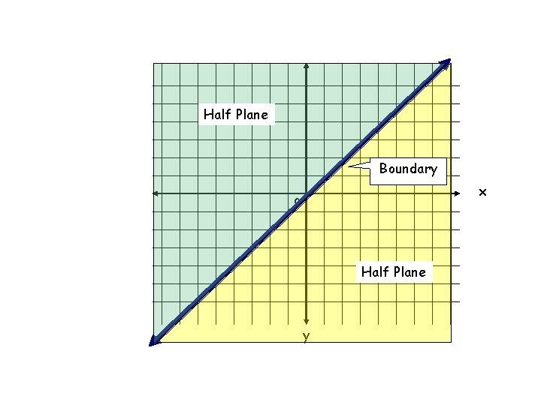
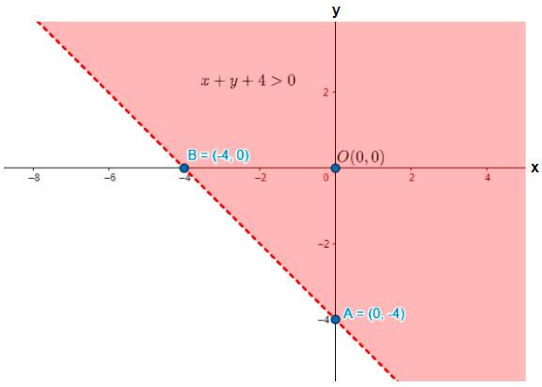
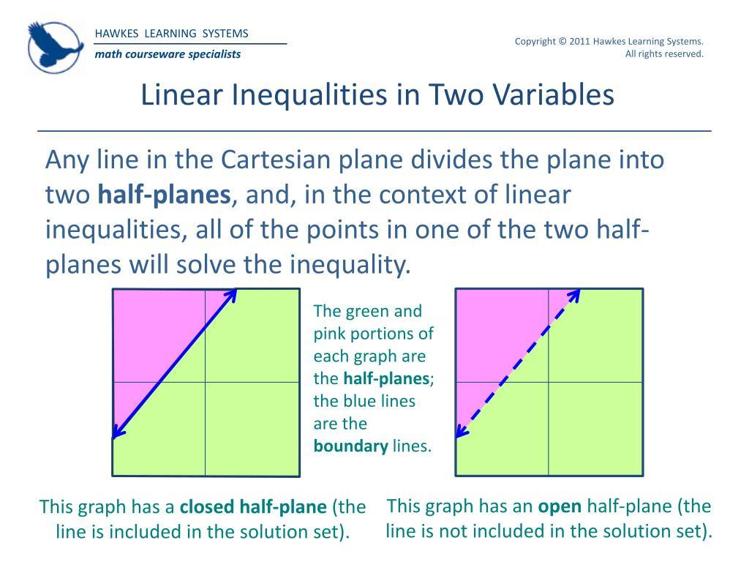
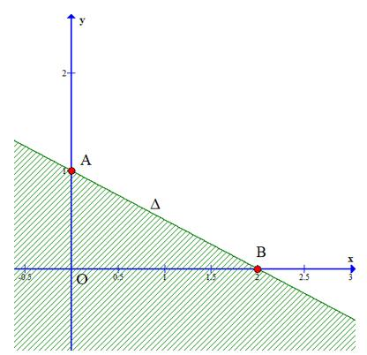
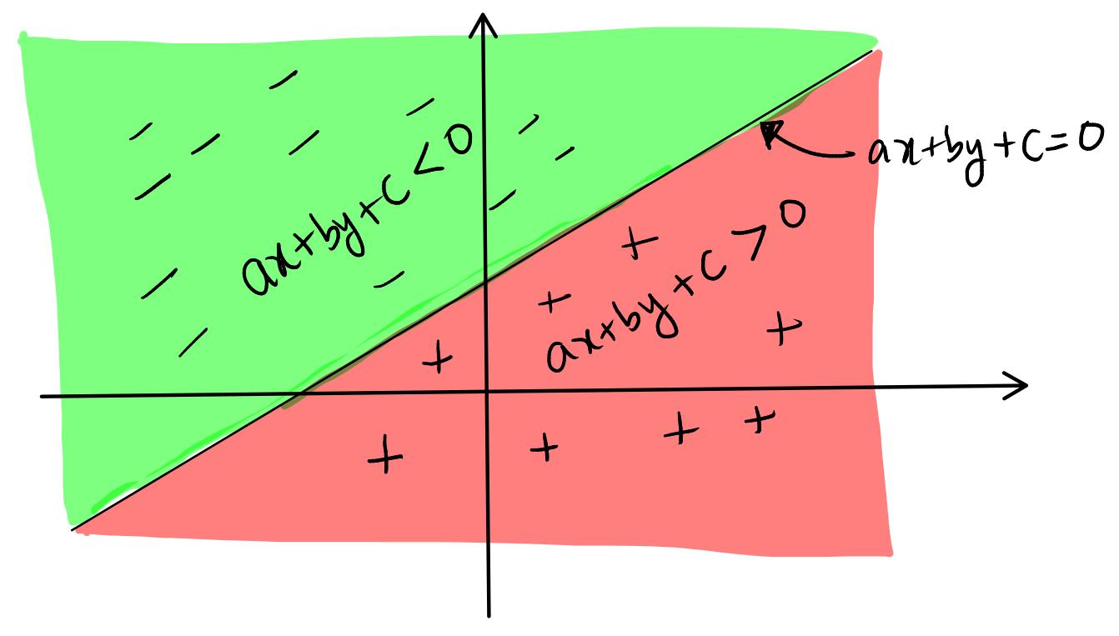
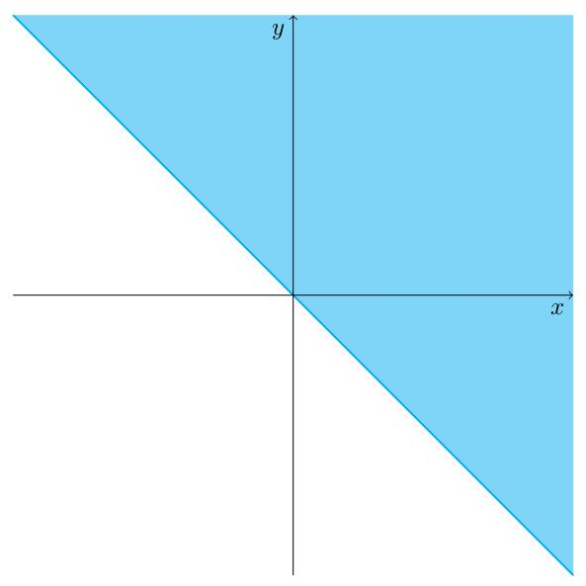

Definition
# Source: AI Source: Provided by: [Data Path: Persons Table -> ID Column: 1, Name_En Column: Motasem Essam] -> From: [ChatGPT] on [7/25/2026]
A Half-Plane is one of the two unbounded regions into which a straight line divides a plane.
When a line is drawn on a plane, it separates the plane into two distinct regions. Each of these regions is called a half-plane, while the line itself forms the boundary between them.
A half-plane extends infinitely in every direction on one side of the boundary line.

Characteristics
# Source: AI Source: Provided by: [Data Path: Persons Table -> ID Column: 1, Name_En Column: Motasem Essam] -> From: [ChatGPT] on [7/25/2026]
A half-plane:
- Is created by a straight line.
- Is an unbounded region.
- Extends infinitely.
- Has a straight line as its boundary.
- Contains infinitely many points.
- May be open or closed depending on whether the boundary is included.

Illustration
# Source: AI Source: Provided by: [Data Path: Persons Table -> ID Column: 1, Name_En Column: Motasem Essam] -> From: [ChatGPT] on [7/25/2026]
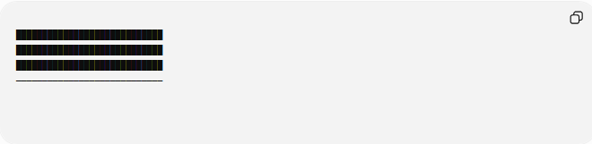
████████████████████████████
████████████████████████████
████████████████████████████
────────────────────────────

- Upper shaded region = Half-Plane 1
- Lower unshaded region = Half-Plane 2
- The line is the boundary.

Mathematical Representation
# Source: AI Source: Provided by: [Data Path: Persons Table -> ID Column: 1, Name_En Column: Motasem Essam] -> From: [ChatGPT] on [7/25/2026]
Consider the line:
$$y=2$$
It divides the plane into two half-planes.
Upper half-plane:
$$y>2$$
Lower half-plane:
$$y<2$$

Closed Half-Plane
# Source: AI Source: Provided by: [Data Path: Persons Table -> ID Column: 1, Name_En Column: Motasem Essam] -> From: [ChatGPT] on [7/25/2026]
Including the boundary:
Upper closed half-plane:
$$y≥2$$
Lower closed half-plane:
$$y≤2$$

Open vs Closed Half-Plane

Open Half-Plane
# Source: AI Source: Provided by: [Data Path: Persons Table -> ID Column: 1, Name_En Column: Motasem Essam] -> From: [ChatGPT] on [7/25/2026]
The boundary line is not included.
Example:
$$x>5$$

Closed Half-Plane
# Source: AI Source: Provided by: [Data Path: Persons Table -> ID Column: 1, Name_En Column: Motasem Essam] -> From: [ChatGPT] on [7/25/2026]
The boundary line is included.
Example:
$$x≥5$$

Examples
# Source: AI Source: Provided by: [Data Path: Persons Table -> ID Column: 1, Name_En Column: Motasem Essam] -> From: [ChatGPT] on [7/25/2026]
Example 1
The line:
$$x=0$$
divides the plane into:
Left half-plane:
$$x<0$$
Right half-plane:
$$x>0$$

Example 2
The line:
$$y=0$$
(the $x$-axis)
creates:
Upper half-plane:
$$y>0$$
Lower half-plane:
$$y<0$$

Example 3
The line:
$$2x+y=8$$
creates two half-planes:
$$2x+y>8$$
and
$$2x+y<8$$

Boundary
# Source: AI Source: Provided by: [Data Path: Persons Table -> ID Column: 1, Name_En Column: Motasem Essam] -> From: [ChatGPT] on [7/25/2026]
The boundary of a half-plane is always a straight line.
Example:
For
$$y>3$$
the boundary is:
$$y=3$$

Real-World Examples
# Source: AI Source: Provided by: [Data Path: Persons Table -> ID Column: 1, Name_En Column: Motasem Essam] -> From: [ChatGPT] on [7/25/2026]
Half-planes appear in:
- Maps divided by borders.
- Property divisions.
- Coordinate systems.
- Road lanes separated by markings.
- Construction site boundaries.
- Computer graphics clipping regions.

Applications
# Source: AI Source: Provided by: [Data Path: Persons Table -> ID Column: 1, Name_En Column: Motasem Essam] -> From: [ChatGPT] on [7/25/2026]
Half-planes are used in:
- Plane Geometry
- Coordinate Geometry
- Analytic Geometry
- Linear Programming
- Computational Geometry
- Computer Graphics
- GIS (Geographic Information Systems)
- Engineering
- Surveying
- Robotics

Advantages
# Source: AI Source: Provided by: [Data Path: Persons Table -> ID Column: 1, Name_En Column: Motasem Essam] -> From: [ChatGPT] on [7/25/2026]
Studying half-planes helps to:
- Solve inequalities.
- Describe geometric regions.
- Define feasible regions.
- Model partitions of space.
- Solve optimization problems.

Limitations
# Source: AI Source: Provided by: [Data Path: Persons Table -> ID Column: 1, Name_En Column: Motasem Essam] -> From: [ChatGPT] on [7/25/2026]
A half-plane:
- Is always unbounded.
- Exists only after a line divides the plane.
- Has infinite area.
- May require inequality notation to describe precisely.

Comparison with Other Region Types
# Source: AI Source: Provided by: [Data Path: Persons Table -> ID Column: 1, Name_En Column: Motasem Essam] -> From: [ChatGPT] on [7/25/2026]
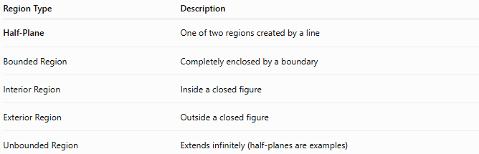
Region Type | Description
Half-Plane | One of two regions created by a line
Bounded Region | Completely enclosed by a boundary
Interior Region | Inside a closed figure
Exterior Region | Outside a closed figure
Unbounded Region | Extends infinitely (half-planes are examples)

Key Points
# Source: AI Source: Provided by: [Data Path: Persons Table -> ID Column: 1, Name_En Column: Motasem Essam] -> From: [ChatGPT] on [7/25/2026]
- A Half-Plane is created when a line divides a plane.
- The dividing line is the boundary.
- Each half-plane:
  - Is unbounded.
  - Extends infinitely.
  - Can be open or closed.
- Half-planes are commonly represented using inequalities.

Conclusion
# Source: AI Source: Provided by: [Data Path: Persons Table -> ID Column: 1, Name_En Column: Motasem Essam] -> From: [ChatGPT] on [7/25/2026]
A Half-Plane is one of the two unbounded regions formed when a straight line divides a plane. The line acts as the boundary, while each half-plane extends infinitely on one side of that boundary. Half-planes are fundamental in plane geometry, coordinate geometry, analytic geometry, computational geometry, linear programming, engineering, surveying, GIS, robotics, and computer graphics, where they are used to represent inequalities, partition space, define feasible regions, and analyze geometric relationships.

